K23_CNPM

G03_QLNS

Quản lý nhân sự (QLNS)

Software Configuration Management Plan

Version: 1.8

Date: 5/5/2020

Product Development Lead: Lò Thị Páo

PLAN UPDATE HISTORY
Version | Date | Brief Description and Reason for Change | Affected Pages | Author
1.0 | release date | Initial release | - | Nguyễn Văn A
1.2 | 12/5/2020 | Update version 1.2 | 3.0 | Nguyễn Văn A

TABLE of CONTENTS

1.0 INTRODUCTION 1
1.1 Purpose 1
1.2 Scope 1
1.3 References 1
2.0 ROLES AND RESPONSIBILITIES 3
2.1 Project Organization 3
2.2 Project Stakeholders (Roles) and Responsibilities 3
2.3 Boards 4
3.0 RESOURCES AND ENVIRONMENTS 7
3.1 Personnel 7
3.2 Plans, Schedule, and Resources 7
3.3 Repository 7
3.4 Support Tools 8
4.0 ACTIVITIES AND APPROACH 10
4.1 CM Phasing and Milestones 10
4.2 Configuration Identification 11
4.3 Configuration Control 12

INTRODUCTION

Purpose
The purpose of this plan is to document what Configuration Management (CM) and Data Management (DM) activities are to be done for the [project name] project, how they are to be accomplished, who is responsible for performing specific activities, when they are to occur, and what resources are required.

Scope
The scope of this CM plan is configuration and data management for the [[project name]] project.

References

Guidance

Check the versions of the GPRs – ensure compliance with the approved version when this plan is being written and finalized. Document the current versions you are compliant with below.
[[project Name]] Software Management Plan/Product Plan (SMP/PP), Document Configuration Identifier, Document Date
[[project Name]] Mission Project Configuration Management Plan, Document Configuration Identifier, Document Date [needed only if associated with a Mission Project, otherwise delete]
[[Mission Acronym]] Project Office Configuration Management Procedures, Document Configuration Identifier, Document Date [needed only if associated with a Mission Project, otherwise delete]
Change Request (CR) Form, Rev. --, 1/1/07
CR Log, Rev. --, 1/1/07
Design Planning and Interface Management (GPR 8700.1)
Process Control (GPR 8072.1)
Product Processing, Inspection, and Test (GPR 5330.1)
Configuration Management (GPR 1410.2B)
Records Control (GPR 1440.7D)
In-House Development and Maintenance of Software Products (GPR 8700.5)
Configuration Management Plan Template, 580-TM-065-01, GSFC

ROLES AND RESPONSIBILITIES

Project Organization
CM takes direction from the Product Development Lead (PDL) and operates within the policies and procedures established by GSFC. See the [[project name]] project plan for further description of the project’s organizational structure.
The [[project name]] CM Officer, is responsible for directing [[project name]] CM for the systems development, test efforts and production support, and will support the [[project name]] Configuration Control Board (CCB). The [[project name]] DM Lead, is responsible for directing [[project name]] DM throughout the life of the project See the organizational chart in the [[project name]] Project Plan.

Project Stakeholders (Roles) and Responsibilities
Stakeholders (Roles) | Responsibility
Team Personnel | Responsible for the implementation of the CM and DM process for their project areas and performs CM/DM activities in accordance with standard processes and procedures as defined for [[project name]] in this CM Plan. May submit Change Requests (CRs).
Product Development Lead (PDL) | Defines the personnel responsible for CM and DM on the [[project name]] project. Directs and interfaces with those persons during the life of the [[project name]] project.
Configuration Management Officer (CMO) | Responsible for coordinating and implementing CM for the [[project name]] project, identifying and controlling configuration items (CIs), establishing baselines upon which a CI is placed under CM control, providing reports as defined in this CM Plan, and providing adequate resources, including tools to support CM activities for the [[project name]] project.
Configuration Control Board (CCB) | Ensures the establishment of the baselines for the CIs and approves changes to these CIs.

Boards

Guidance
Identify the configuration control board(s) established for the project and program organization, e.g., CRB (Change Review Board), CCB, or Local CCB (LCCB or IRB – Internal Review Board).
Reference any charters, Memoranda of Understanding, or any program directives that establish the CCBs. Ensure that the correct nomenclature for the board(s) is (are) used, as the project may interface with higher and lower-level agency control boards.
It is understood that each organization has a unique hierarchy and linkage among boards. It may also be helpful to include a figure, such as Figure 2-1 below, that illustrates the linkage among the boards. Note that in this example, local, or project-level CCBs may include separate CCBs for Hardware and Software.
The sections below provide an overview of the functions, responsibilities, and authority of the CCBs.

Guidance
This is the review board at the higher level above this project. Use the appropriate nomenclature for “CCB”, “Program Manager” etc.

Configuration Control Board
Guidance
Change control responsibility may be delegated between the PDL, who may coordinate the configuration control of related projects, and Local CCBs, who manage changes at the specific project CI level. If this is the case, include descriptions of the Local CCBs and the scope of their responsibility, and include the Local CCBs in the organization description in the CM Plan.
If there are different levels of CCBs describe them here.
A CCB has been established to authorize changes to baselined documentation, hardware and software and for in-development products. The CCB is chaired by the PDL and the membership consists of the CMO and senior team members who provide broad interdisciplinary representation. CCB members are: put names or roles of members here. The PDL requests the participation of additional personnel as necessary depending on the CR under consideration.
The CCB supports the PDL and includes technical and administrative representatives who recommend approval or disapproval of proposed engineering changes to a CI's current approved configuration and its documentation. The board also recommends approval or disapproval of proposed deviations from a CI's current approved configuration and its documentation.
Guidance
If the CCB meets regularly, state how often (this may vary according to the phase of the project). If it does not meet regularly, use the text below.
CCB meetings are called as necessary by the Chair depending on the quantity of Open CRs. The CCB will meet at least quarterly.
The Configuration Management Officer (CMO) serves as coordinator and scribe to the board and provides status accounting reports to the CCB and updates the status accounting information to reflect CCB decisions.
Guidance
Modify the figure below with to highlight your projects CCB, and any subsidiary team CCB(s) under your project’s control. Use appropriate nomenclature and indicate the Chair’s name(s).

Mission Project Level CCB
Sub-System Level CCB
Sub-System Level CCB
Sub-System Level CCB
Local CCB
Local CCB
Local CCB

Figure 2-1. Mission Project name Configuration Boards

CCB Responsibilities
The CCB has authority for managing the project's product through the performance of the functions listed below:
- Authorize establishment of configuration baselines and identification of CIs.
- Represent interests of project management and all groups who may be affected by changes to the baselines.
- Assign, review, and provide for disposition of action items.
- Serve as a source for the coordination of technical expertise for the project.
- Determine or review the availability of resources required to complete the proposed change or modification, assess the impact of the proposed change upon the system, examine cost considerations, and determine the impact of the change on development and test schedules.
- Analyze change request impact, benefit and necessity.
- Approve changes – or disapprove – as appropriate.
- Monitor the status of open change requests

Other Boards
N/A
Guidance
Add an additional section heading and subheadings for responsibilities and composition for each external board (e.g., Operational Advisory Group/Maintenance Advisory Group) or subsidiary board.

RESOURCES AND ENVIRONMENTS

Personnel
The CM effort for this project is person-year effort or indicate the amount of effort if it is less than 100% for a single person- ensure the effort agrees with the project Work Breakdown Structure.
Personnel involved in CM activities will be familiar with and apply the standards and guidelines referenced in Section 1, are familiar with the CM Process, and the chosen CM tools. Required training is listed in the training matrix in the SMP/PP.

Guidance:

For Classes of Software other than A, B, and C the required training for the CM personnel should be listed here.

Plans, Schedule, and Resources
The CM schedule is closely coordinated with the product schedule. CM audits will be performed at the conclusion of each new phase of development to verify that the CM procedures are correctly implemented as defined in this document. CM audits are scheduled in the project schedule.
The estimated CM budget for this project is documented in the annual budget identified in the SMP/PP. The PDL will periodically review actual budget expenditures against planned expenditures and resolve any issues.
The CMO coordinates with the PM to ensure that CM activities are conducted in concert with the appropriate project activities and maintained in the project schedule.

Repository
The [[project name]] Repository structure is shown in Figure 3-1 with each of its main sub-folder elements described.

Guidance:

An example of a directory structure is provided in this template. If this example is followed it should be placed on a shared server. If a tool, or web-based solution is chosen, describe it and provide a screen-shot of its organization and/or layout.

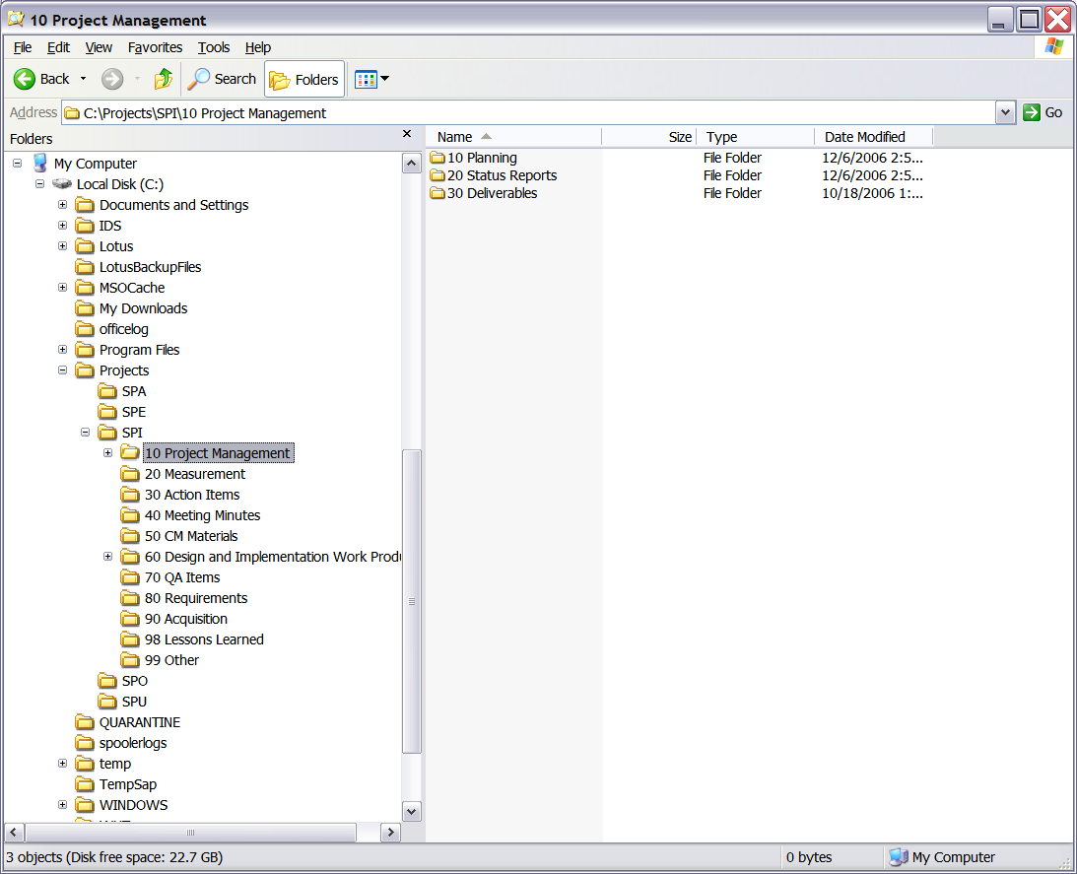
Guidance:
The particular entries, their order, and organization are up to you. Do what is most useful for you and your team.
Figure 3-1. [[project name]] repository structure

Software baselines are maintained in the CM support tool described in the next section.

Support Tools

Guidance
The tools may be manual (consisting of controlled ledgers, notebooks, spreadsheets, or similar items) or automated (comprising a computerized database or similar set of tools and capabilities) or be a combination of the two.
Multiple tools may be used to manage code, requirements, design, code, change requests, documentation, etc. List all that are need for CM and change control (for both documents and software).
The detailed description of how to use the CM system may be separately documented as individual CM procedures and should be referenced (e.g., procedures for storage and retrieval of CIs, archiving and retrieving CM records, creating CM reports).

The configuration management support tool used on the [[project name]] project is [SourceSafe, VCS, Rational….] for source code and [Rational, Docushare, website…] for CCB controlled documents.
The data management support tool for the project is [ClearCase, or repository, web-site….].

ACTIVITIES AND APPROACH

CM Phasing and Milestones
Guidance
The author may choose to describe this section of the document using a combination of text and graphics, text only, or graphics only. This section should be tailored to describe CM activities within the system development life cycle phases covered by this version of the plan. The sample text in this section describes typical activities.
The purpose of this section is to ensure that CM activity is appropriate to the scope and timing of the [[project name]] project activity.
Non software items will be version controlled by the author until the item is ready for signature and then will be placed under more formal control (if appropriate as identified in Attachment 1).
Software elements will be version controlled by the developer until the item’s unit test is completed and then placed under version control within the CM tool. Upon the completion of the development phase the item is placed under CCB control.
Table 4-1 identifies the planned baselined items, when they will be baselined, and when they will be considered for revision by milestone in relation to project activity for [[project name]]. Items marked with a “P” for the controlling organization are expected to be controlled by the Mission Projects CCB, otherwise it is controlled by the local CCB.
Milestones:
- Requirement: 4/5/2020
- A&D: 10/5/2020
- Implement: 20/5/2020
- Test & Fix bug: 5/6/2020
- Package&Release: 10/6/2020
- Project Closing: 17/6/2020
Guidance
This list contains elements found through initial development and all phases of a project. For a project already in operations and maintenance, the phases may be the same for the incremental changes, and the baselines may be fewer.
Create your list of planned baselined Items, see below for example. A list of actual baselined items is maintained on a regular basis in the DML. Actual baselines are defined in Version Description Documents and revision histories (for documents).
Table 4-1. Planned CM Baselines
Guidance
All the baselined items and versions shown by phase are for example purposes only -- the contents of this table may look quite different.
Baselined Items |  | New Versions Planned by Phase
Baselined Items | Org. | Concept | Requirements | Design | Implementation | System Testing | Acceptance Testing | Operations
SMP/PP | P | • | •
Configuration Management Plan | P | • | •
Test Plan | P | • | •
Software Requirements Document | P |  | • | •
Software source code files, command files |  |  |  |  | • | • | • | •
Build Generation Files (Make, Link, etc.) |  |  |  |  |  | • | • | •
Database |  |  |  |  |  | • | • | •
Development Tools (e.g., tools to build stored command loads, etc.) |  |  |  |  |  | • | • | •
Functional Design Documents |  |  | •
Detailed Design Documents |  |  |  | •
Test Scenarios |  |  |  | • | • | • | • | •
Test Results |  |  |  |  | • | • | • | •
Systems Test data files |  |  |  |  | • | • | • | •
Test Procedures |  |  |  |  |  | • | • | •
Test Data Supplied by External Organizations |  |  |  |  |  | • | • | •
Software Acceptance Test procedures |  |  |  |  |  |  | •
Software Acceptance Test Report |  |  |  |  |  |  | • | •
Development Facility COTS Software |  |  |  |  | • | • | • | •
Software test tools |  |  |  |  | • | • | • | •
Test data files |  |  |  |  | • | •

Configuration Identification

Identifying configuration items
For a complete list of all configuration items and data items for the [[project name]] project, see [[project name]] Data Management List (DML) (initial version Attachment 1). The updated [[project name]] project DML will be maintained in the “[name of your project’s CM library]” repository folder. [Update the location for your project]

Naming configuration items
The Naming Convention to be used on the [[project name]] project is: Base.ss.uu, where:
Base – Not more than 40 alphanumeric characters that define the software or system media and its content, document, or other work product
Suffix - ss.uu -- a period followed by 2 alphanumeric characters, another period and another 2 alphanumeric characters, which provide the revision / version of the software or system work product, for example:

- First two characters (ss) of the suffix define a major release or revision as defined by the project;
- Second two characters (uu) of the suffix define a minor release, update or revision as defined by the project.
Guidance
Tailor this section with your project’s naming conventions.

Acquiring configuration items
The software project team will copy the commercial off-the shelf (COTS) software, list COTS software acquired by the project here to the project’s Project Library. A complete record of this acquired software is maintained in the Data Management List (DML) see Attachment 1 of this document.

Baseline Documentation
Version Description Documents (VDD’s or release documentation) document the contents of delivery baselines. These document the specific contents of baselines including versions of software elements and documentation.

Configuration Control
Configuration control is the systematic evaluation, coordination, approval or disapproval, and implementation of all changes after formal establishment of an item’s baseline. All changes to CCB controlled baselines require the documented approval of the CCB.
Guidance
Use the appropriate nomenclature/acronyms for your project, and describe how things are done on your project.

4.3.1 Requesting a Change
A key element of the change control process is the CR. The CR form is used to describe changes requested to the configuration item.
After a CR form receives CCB approval for changes the CR (annotated with the name of the person to whom it is assigned) is sent by the CCB representative to the individual assigned to resolve the problem or make the change. All CRs are tracked to closure by the CCB representative for the [[project name]] project using the CR Log as the primary tracking mechanism.

4.3.2 Levels of Control
Levels of control for work products are:
- CCB -- Documents that are CCB controlled
- Version -- Documents, information or software managed in a CM system or by additional processes and released such that versions/releases are maintained. These artifacts do not require approval by any CCB
- Stored -- All data that is not CCB Controlled or Version Controlled falls into this category; this includes data generated in the course of doing business, such as meeting minutes, monthly reports, metrics, notes, draft reviews, emails, etc.
A level of control is assigned to each work product in the Data Management List. Items not assigned a level of control (items not on the List) are not controlled.

